
Our changing world |  | Year 6 |  |  | Unit 3
Assessment task — Explaining changes to the surface of Earth
Name |  |  | Class
Teacher |  |  | Date

Assessment resources
- assessment task Explaining changes to the surface of Earth: Student resource (Beaufort wind scale)
- pencil, eraser and ruler
Part A: Tropical cyclones
Below is a graph of the average wind speeds of Tropical Cyclone Sans Nom recorded over a period of two weeks.
January
Average wind speed (km/h)
Average wind speeds of Tropical Cyclone Sans Nom
Cyclone category table
Category | Average wind speed (km/h) | Strongest gust(km/h)
1 | 63–88 | <125
2 | 89–117 | 125–164
3 | 118–159 | 165–224
4 | 160–199 | 225–279
5 | >200 | >280
- Use the graph and table and the assessment task Explaining changes to the surface of Earth: Student resource (Beaufort wind scale) to help answer the following questions.
- Tropical Cyclone Sans Nom crossed the Queensland coast near a large town on Tuesday 15 January at 6 am. What category was Tropical Cyclone Sans Nom on Tuesday 15 January?
- What level of damage would be sustained by the community during this time? Explain your reasoning.
- Interpret the graph to explain how the data collected before and after 15 January could be useful.
d) What is a limitation of the Beaufort wind scale?
e) Why may extending the Beaufort wind scale be useful?
2. The map below shows a tropical cyclone over the Coral Sea off the Queensland coast. After looking at the map, a friend of yours states: ‘I predict that the cyclone will cross the Queensland coast near Cairns at 11 o’clock on Tuesday morning.’
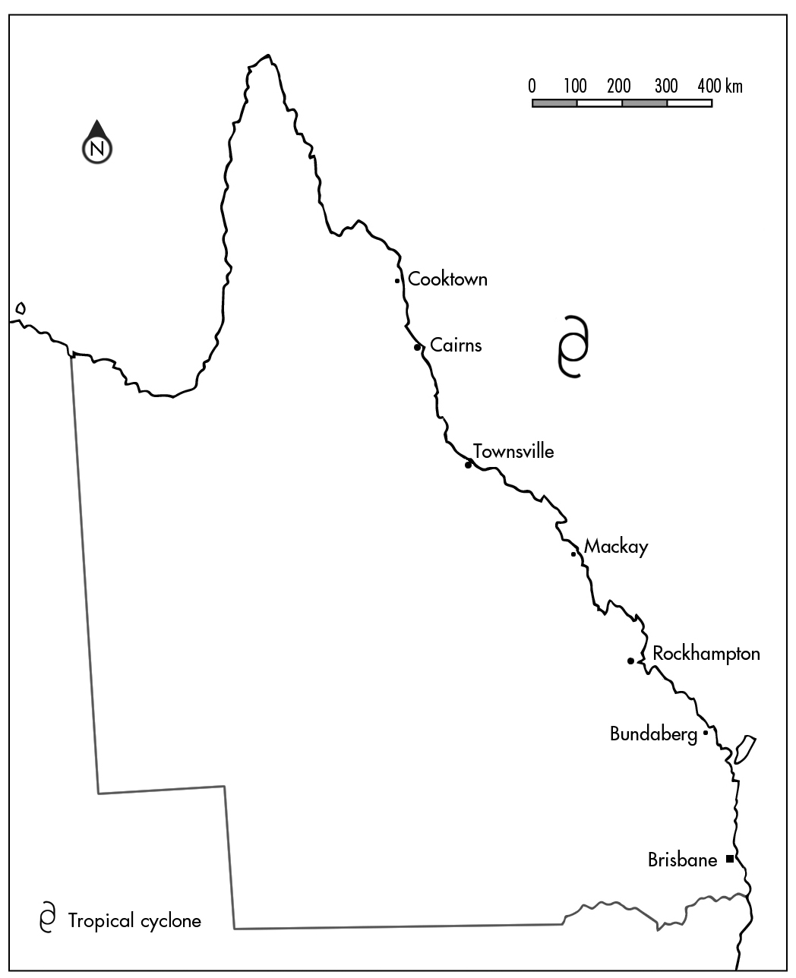
- Is this prediction accurate? Why or why not?
- List additional research that could be done to improve the accuracy of this prediction.
- Justify how this additional research can be used to create a more accurate prediction.

Part B: Coping with natural disasters
- During the course of exploring natural events you have discovered how people from across the world have developed methods to cope with different natural events.
The following passage explains a building technique used in an earthquake-prone area in northern India:
The Kashmir region in northern India experiences frequent earthquakes. The people who live in this area have developed two unique construction practices for making their houses safer during an earthquake.
These techniques, known as the Taq and Dhajji-Dewari systems, have been shown to provide earthquake-resistant qualities to buildings.
In the Taq system, large pieces of wood are used as horizontal supports embedded into the walls. These supports are located at floor level and at the top of windows. They tie together all of the elements of the building, allowing the entire structure to move during the earthquake. This prevents spreading and cracking of the brick walls.
In the Dhajji-Dewari system, timber frames for separating the brick and mortar walls into small parcels are used. The timber frames not only have vertical and horizontal supports, but also have diagonal cross beams, which divide the walls into various small panels. The most important characteristic of this type of construction is the use of lean mud mortar.
A common practice in the region is to use the Dhajji-Dewari system in the upper storey walls, especially below peaked roofs.
Reference: Indigenous knowledge for disaster risk reduction: good practices and lessons learned from experiences in the Asia- Pacific region (UNISDR) by Myers, K & Watson, P, pp 5-8. © 2008 United Nations. http://www.unisdr.org/files/3646_IndigenousKnowledgeDRR.pdf
A town on the central coast of New South Wales has recently suffered an earthquake and experienced a large amount of damage to houses that were constructed from modern-style bricks and mortar.
- Describe how the residents of the New South Wales town could use the knowledge of the Taq or Dhajji-Dewari building techniques to rebuild their houses with more earthquake-resistant designs.
- Explain how indigenous stories contribute to the scientific understanding of natural disasters.
Part C: The changing surface of Earth
4. The three sets of images below show different locations before and after an earthquake. Explain what changes have occurred to Earth’s surface because of the earthquake. Remember to include your science knowledge and scientific language in your explanation.
a) | 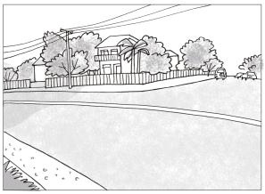 | → | 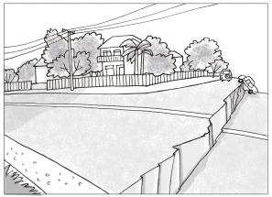
b) | 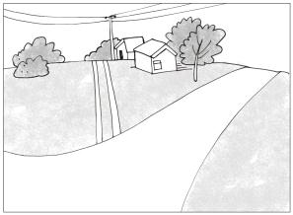 | → | 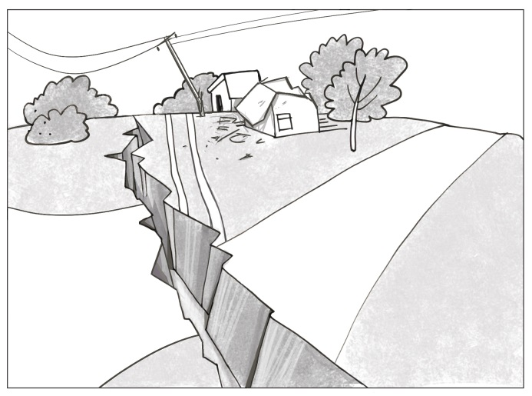
c) | 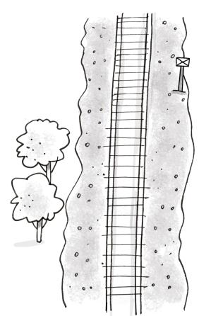 | → | 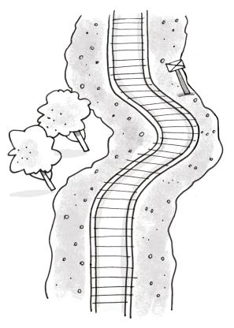
d) In addition to the previous images, what other sources of evidence would suggest that the changes to Earth’s surface were caused by earthquake?
e) Refer to image C (the one with the train tracks). If a fence was placed parallel to the train tracks predict what the track would look like after the earthquake. Explain your prediction.

Year 6 Science: Unit 3 — Our changing world: Explaining changes to the surface of Earth | Name:
Purpose of assessment: To explain how natural events cause rapid changes to Earth’s surface and identify contributions to the development of science by people from a range of cultures. To identify how research can improve data.
Science Understanding |  |  | Science as a Human Endeavour |  |  |  |  | Science Inquiry Skills
Earth and space sciences |  |  | Nature and development of science |  |  |  |  | Processing and analysing data and information |  |  |  | Communicating
Explain how natural events cause rapid change to Earth’s surface. |  |  | Identify historical and cultural contributions. |  |  |  |  | Interpret data identifying where research could improve the data. |  |  |  | Communicate ideas and findings.
 |  | Applies knowledge to make a reasoned prediction. |  |  |  | Explains how science knowledge from other cultures contributes to our understanding of natural events. |  |  |  | Justifies how additional data from research provides a more accurate prediction. |  |  |  | Communicates, using accurate scientific language and appropriate representations comprehensively. | A
 |  | Links evidence of change to the type and severity of a natural event. |  |  |  | Describes how contributions have led to scientific understanding of natural events. |  |  |  | Accurately interprets data identifying examples of how research improves data. |  |  |  | Communicates ideas using scientific language and representations. | B
 |  | Explains how natural events cause rapid change to Earth’s surface. |  |  |  | Identifies historical and cultural contributions. |  |  |  | Interprets data identifying where research could improve data. |  |  |  | Communicates ideas and findings. | C
 |  | Identifies a change to Earth’s surface caused by a natural event. |  |  |  | Identifies a problem that may result because of a natural disaster. |  |  |  | Suggests additional possible data |  |  |  | Uses everyday language. | D
 |  | States a change. |  |  |  | States a contribution to science. |  |  |  | States data. |  |  |  | Uses fragmented language. | E

Feedback:

